In this exercise you will log into the Contoso web site and configure profiles. \*\*Pictures are located in the Additionaldatafiles/employeepic folder

1. Sign in to the Contoso portal as Carl and:
   1. Upload a photo of Carl
   2. 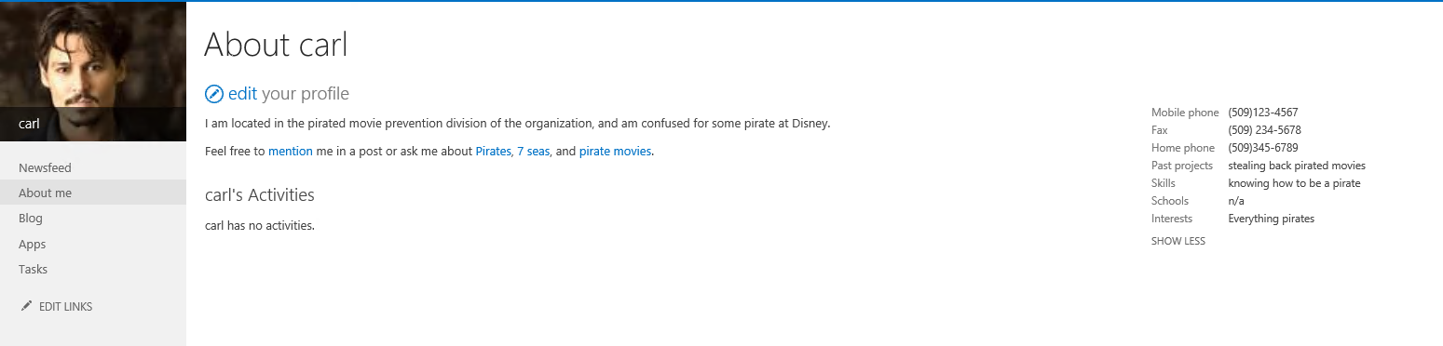Add profile information about Carl
   3. Start a conversation in the Newsfeed

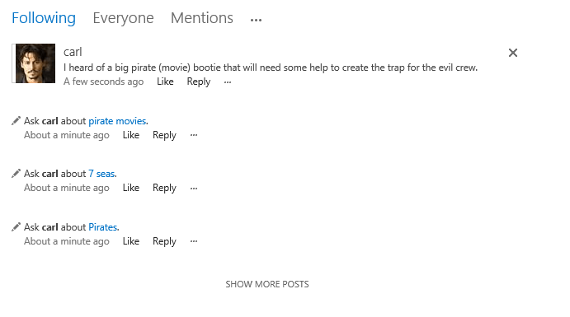

1. Log out and sign in as Cathy
   1. Upload a photo of Cathy
   2. Add profile information about Cathy

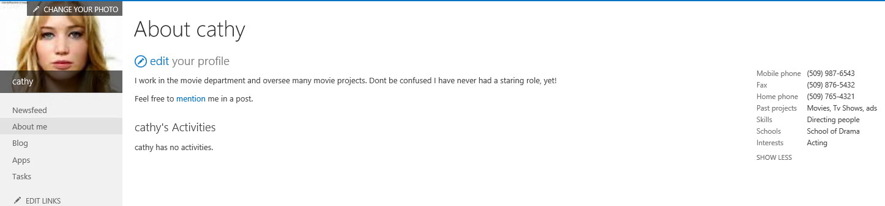

* 1. Start a conversation

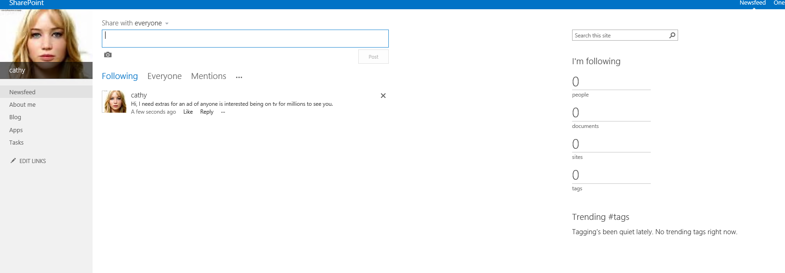

1. Sign in as Administrator
   1. Upload a photo

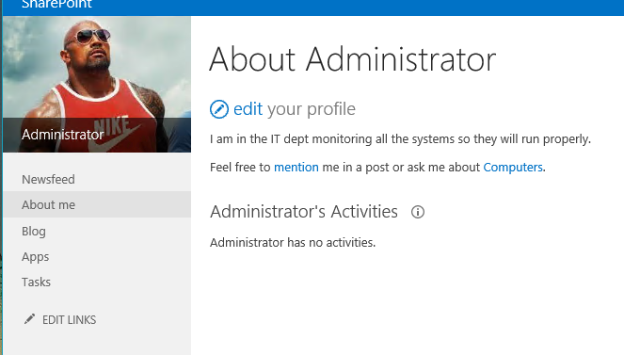

* 1. Follow Cathy
  2. Follow Carl

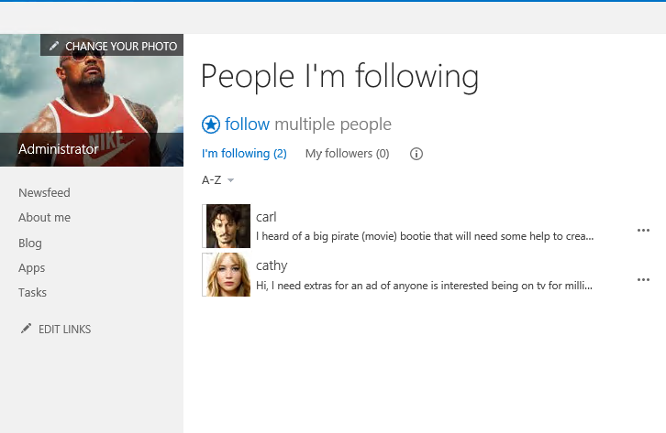

* 1. Add two documents

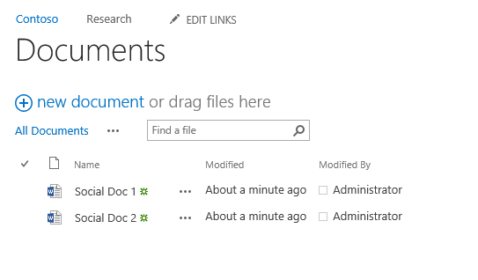

* 1. Share one of the documents with Carl

